Q1) 0xfffef094
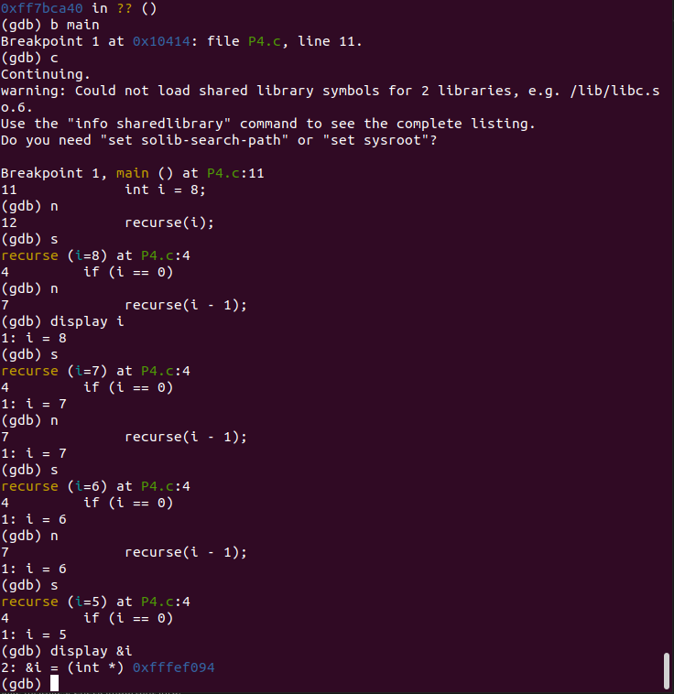

Q2) 12 bytes
By converting into hexadecimal,
0xfffef0a0 - 0xfffef09c = 12 bytes
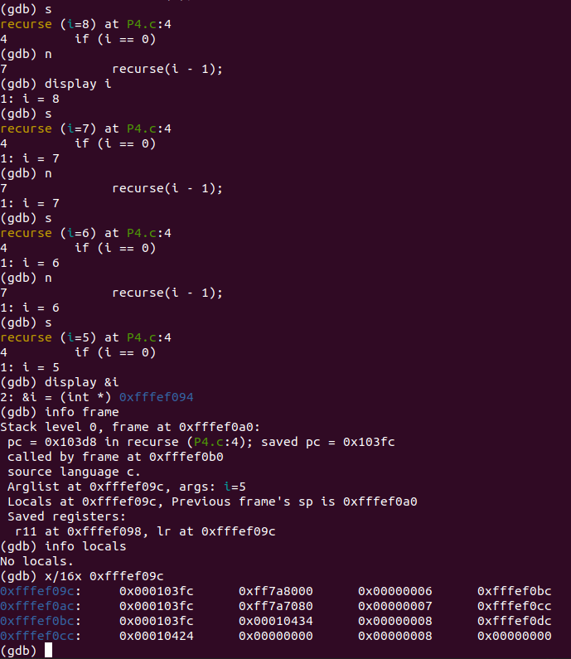

Q3) Register: r0, Location: 0x4
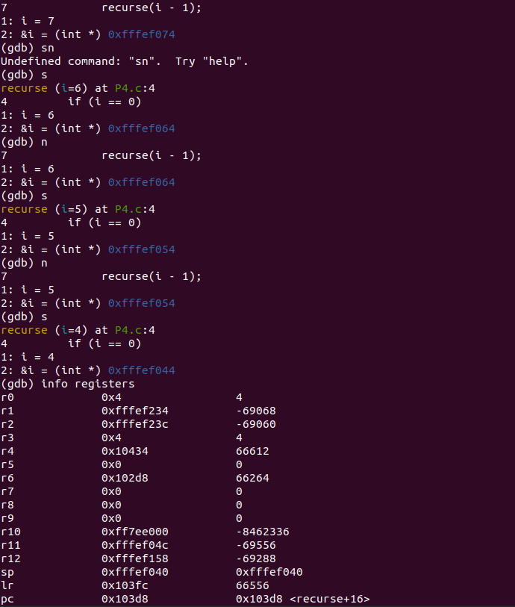
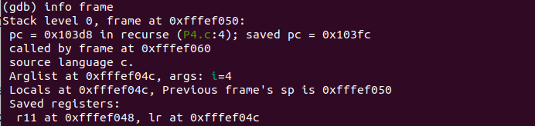
Q4)
#include <stdio.h>

int recurse(int i) {
int extra[10]; // Allocate 10 integers (10 * 4 bytes = 40 bytes)

if(i == 0)
return 0;
else
recurse(i - 1);
}

int main() {
int i = 8;
recurse(i);
}

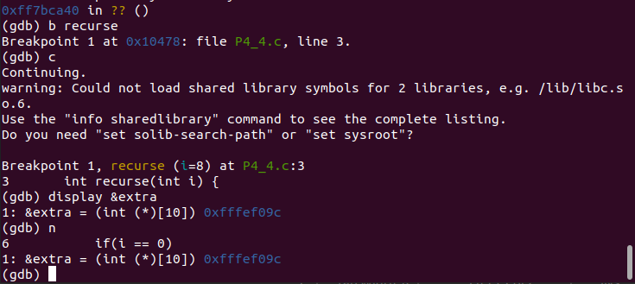
Starting Address location: 0xfffef09c

